**ESE**

Opon source : <http://vedder.se/2015/01/vesc-open-source-esc/>

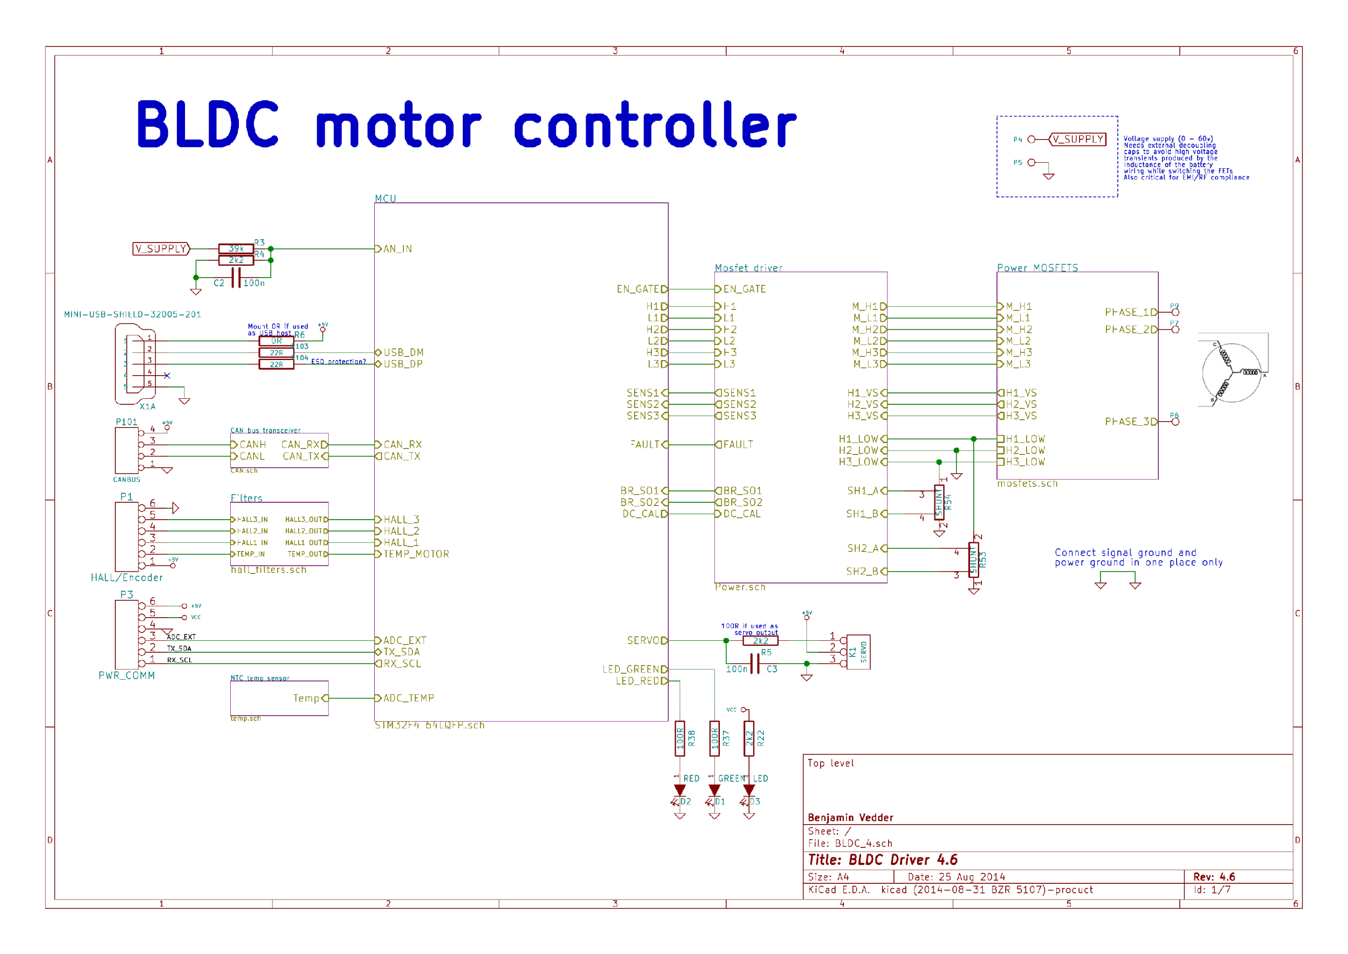

The Front side of the PCB

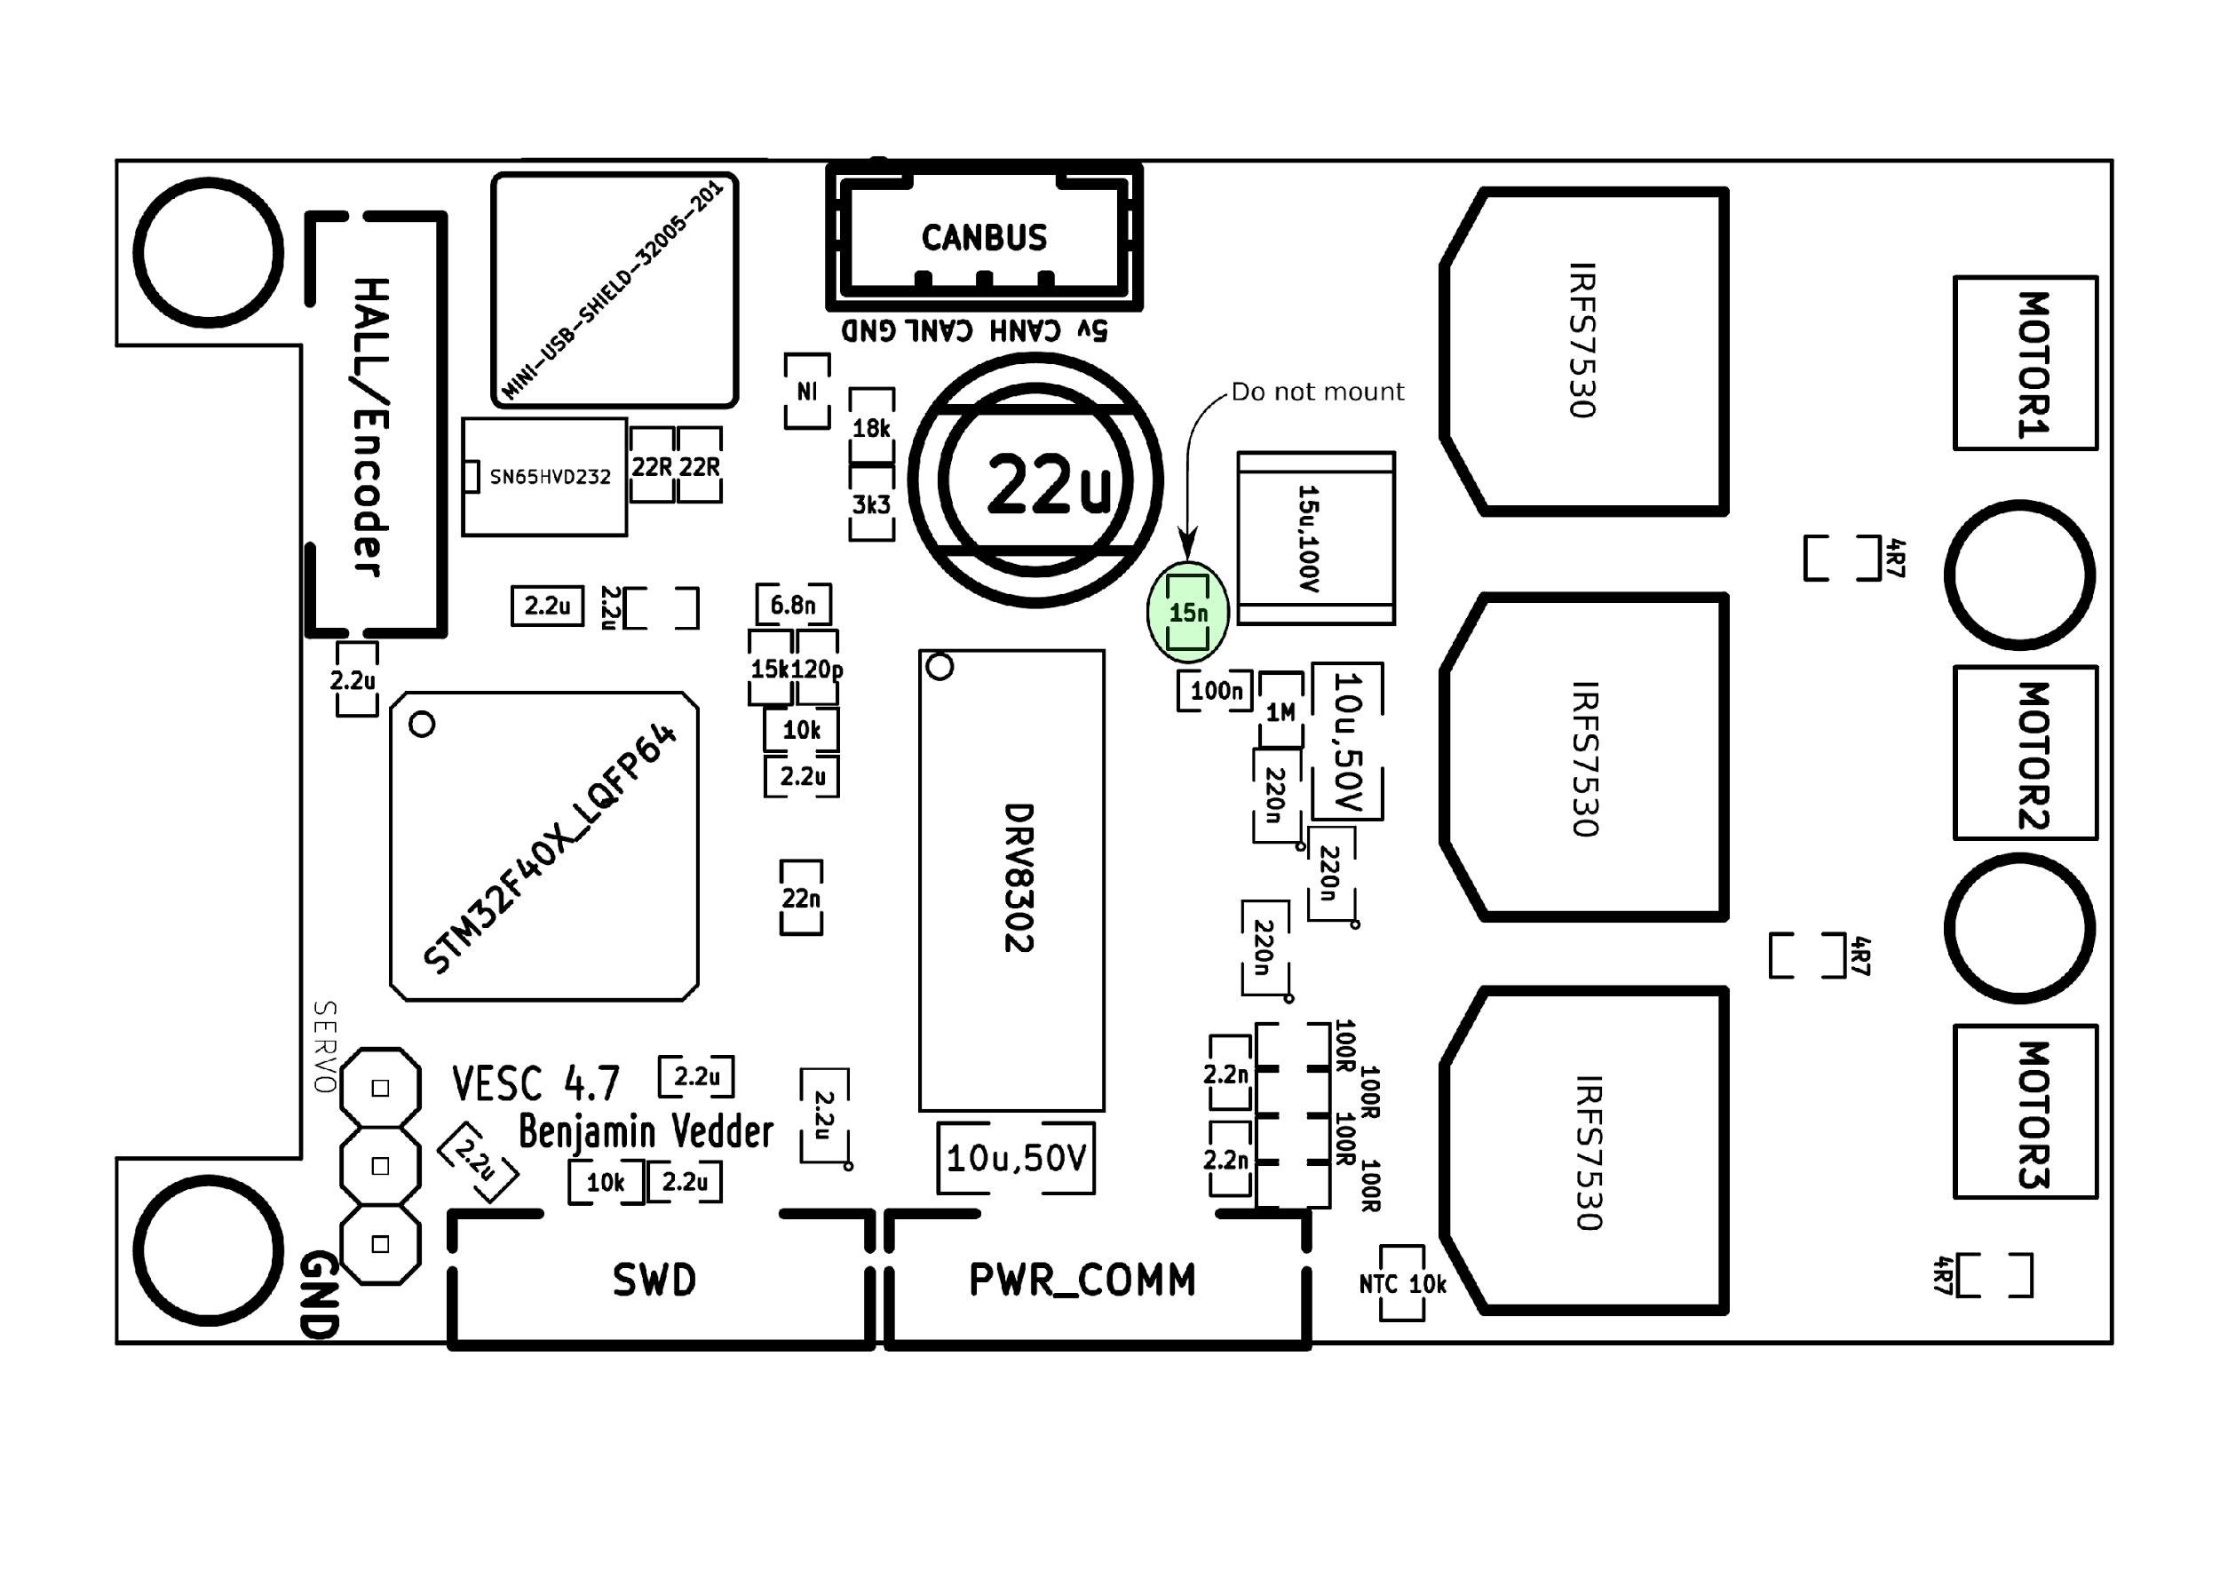

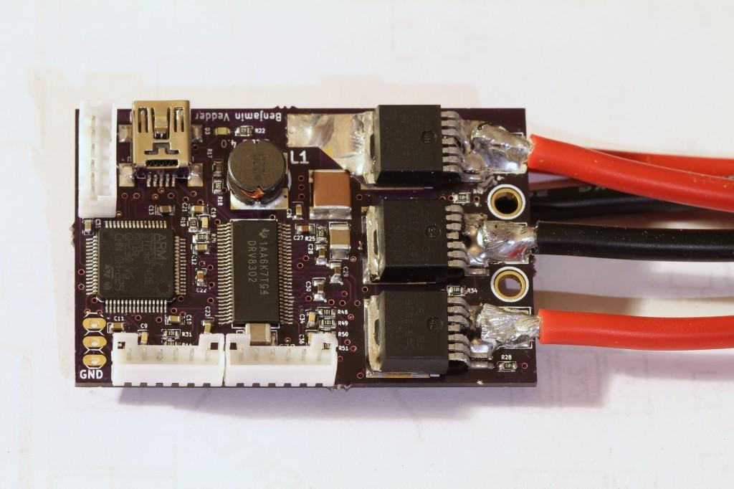

The Back side of the PCB

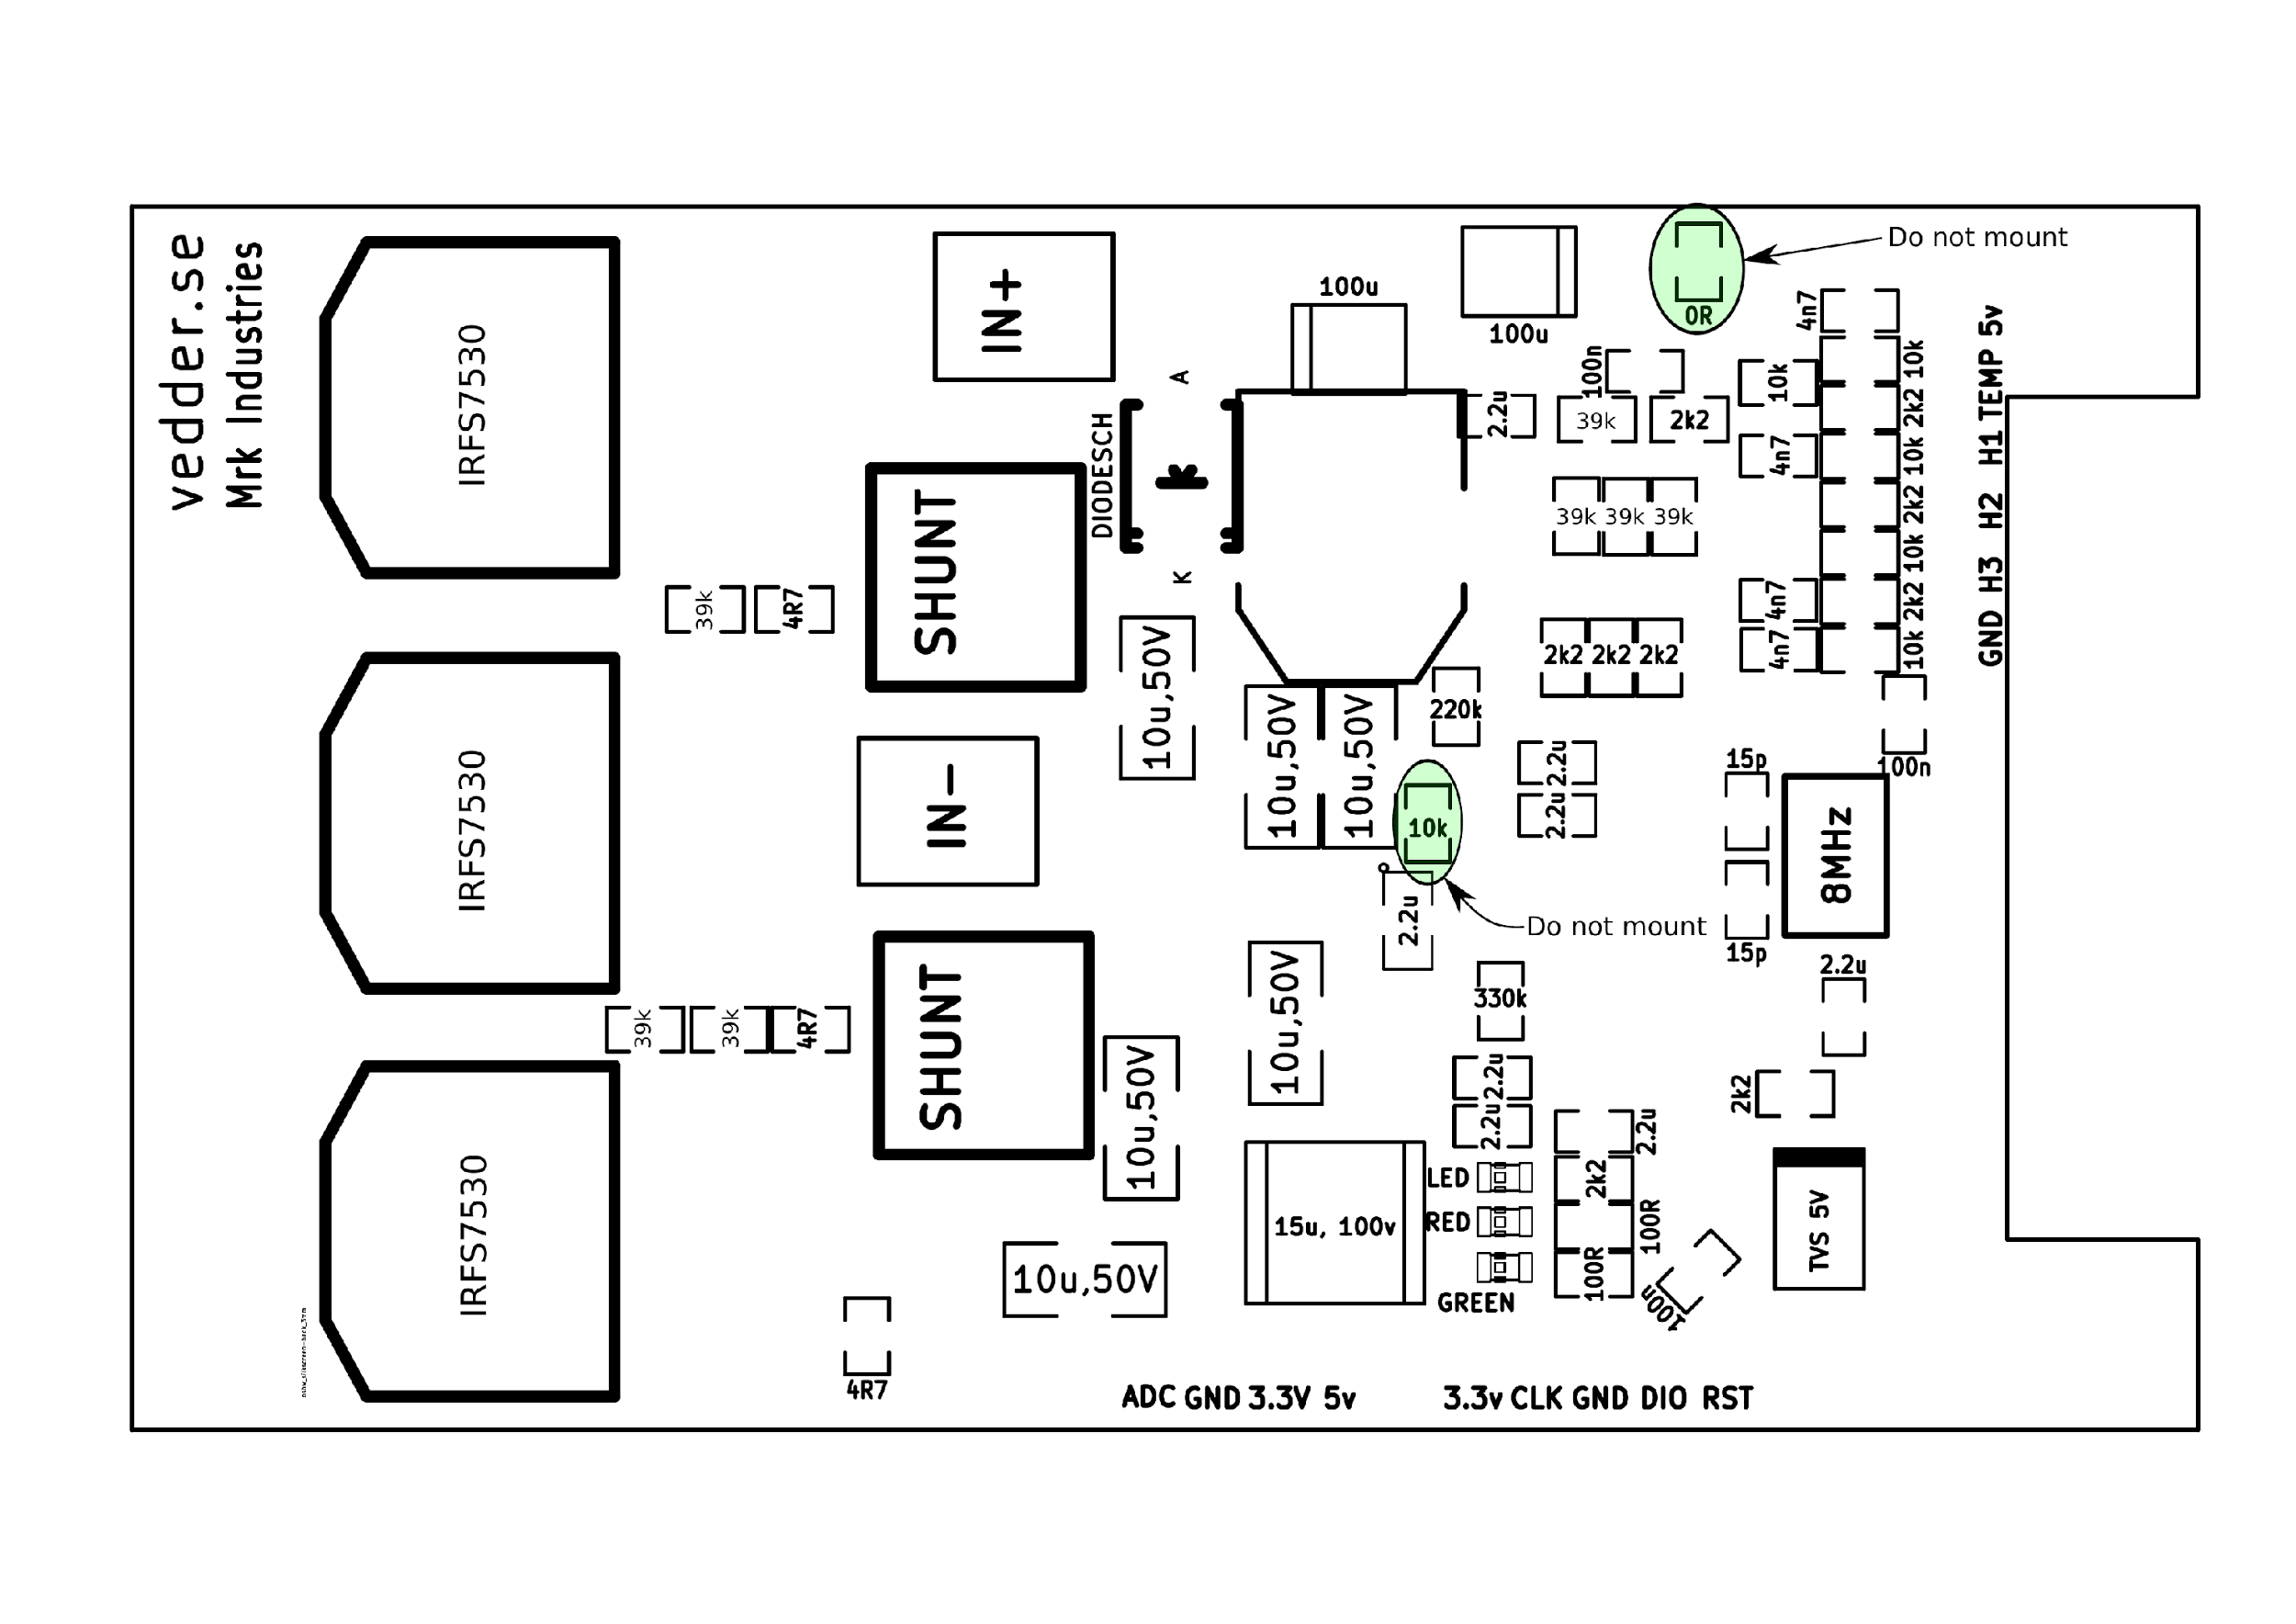

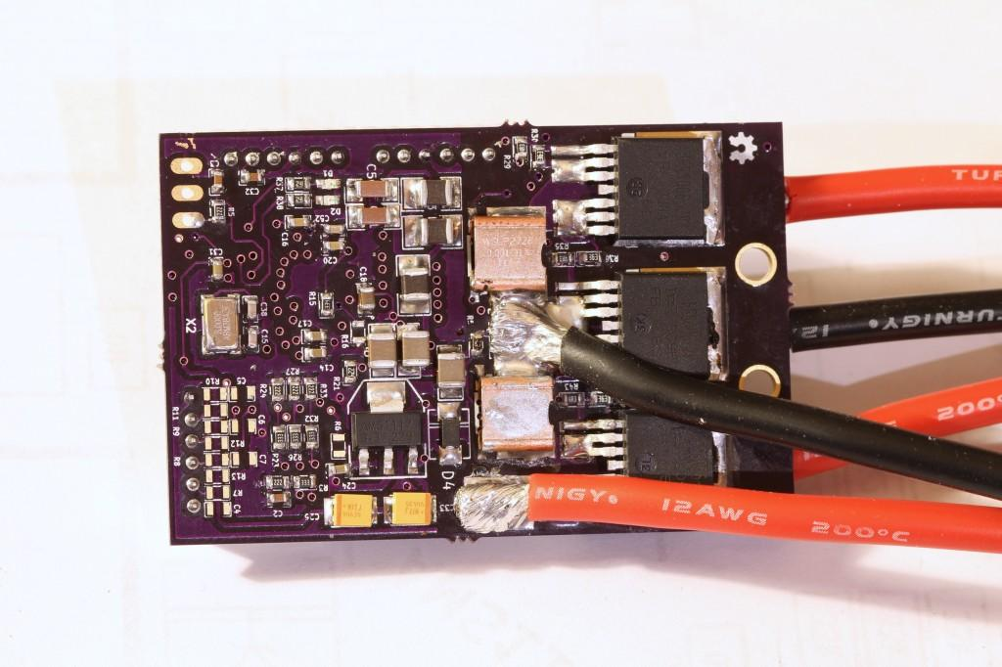

**Mosfets Gate Driver**

The DRV8302 is a gate driver IC for three phase motor drive applications. It provides three half bridge drive, each capable of driving two NMOSfet that have one high side and one for low side.

The date driver uses automatic hand shaking when high side and low side FET is switching to prevent current shoot through.

Three half bridge drive mean can operating high voltage, high speed,driving mosfet

The The DRV8302 includes two current shunt amplifiers for accurate current measurement .

The DRV8302 also have a Buck converter with adjustable output and switch frequency to support MCU or additional system power need

**Shunt to Shunt:**

The DRV8302 includes **two current shunt** amplifiers for accurate current measurement. The current amplifiers support bi-directional current sensing and provide an adjustable output offset of up to 3V.

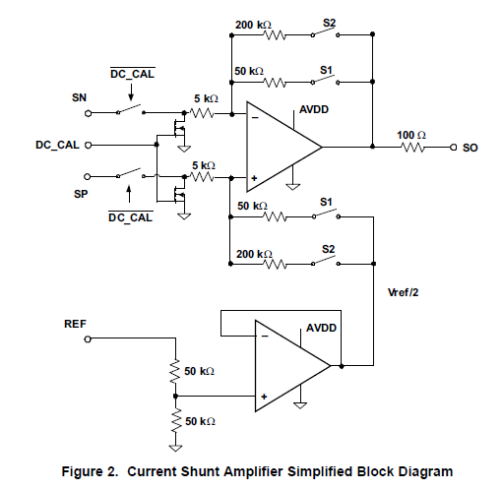

A **buck converter** is a voltage step down and current step up **converter**. The simplest way to reduce the voltage of a DC supply is to use a linear **regulator** (such as a 7805), but linear regulators waste energy as they operate by dissipating excess power as heat

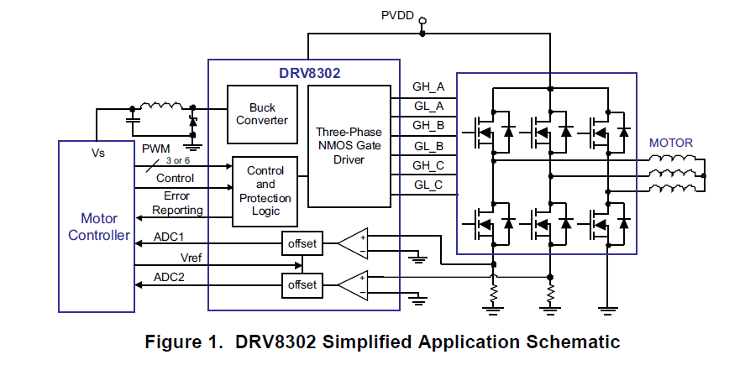

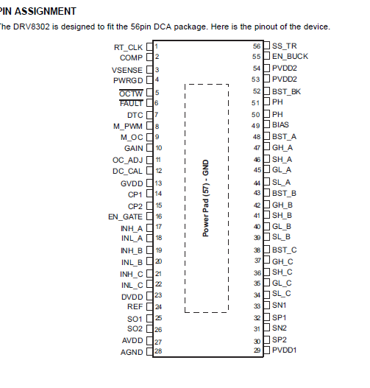

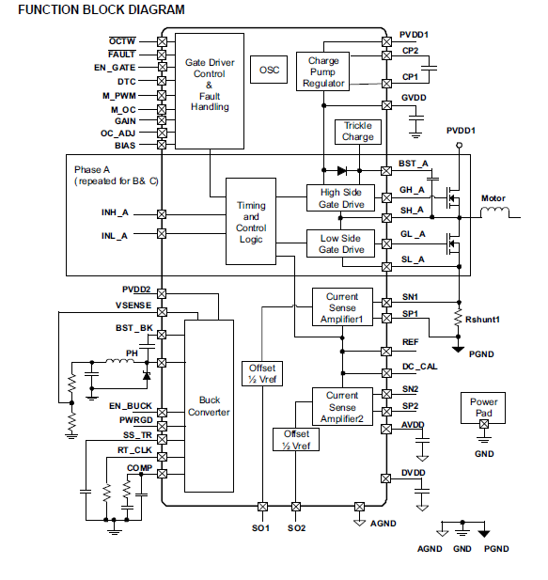

**Power Mosfet**.( use to convert a low voltage to high voltage.):

A major advantage of the Power MOSFET is its very fast switching speeds

The drain current is strictly proportional to gate voltage so that the theoretically perfect device could switch in 50ps - 200ps, the time it takes the carriers to flow from source to drain

. A MOSFET begins to turn off as soon as its gate voltage drops down to its threshold voltage

The power MOSFET is the most widely used low-voltage (that is, less than 200 V) switch. It can be found in most [power supplies](http://supply), [DC to DC](http://converter)

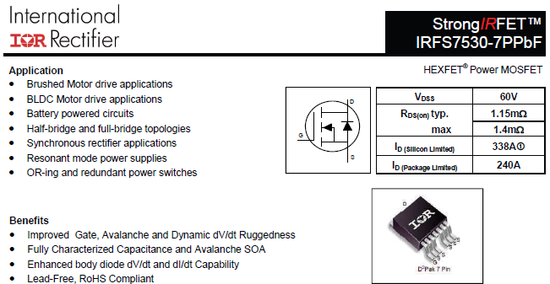

**Tranreciever: $1.10 from the VESC**

**A controller area network (CAN bus) is a** [**vehicle bus**](http://en.wikipedia.org/wiki/Vehicle_bus) **standard designed to allow** [**microcontrollers**](http://en.wikipedia.org/wiki/Microcontroller) **and devices to communicate with each other in applications without a** [**host computer**](http://en.wikipedia.org/wiki/Host_computer)**. It is a** [**message-based protocol**](http://en.wikipedia.org/wiki/Message-based_protocol)**, designed originally for automotive applications, but is also used in many other contexts.**

<http://www.mouser.com/ProductDetail/Texas-Instruments/SN65HVD232DR/?qs=sGAEpiMZZMutXGli8Ay4kMj2H7jHcXU%2fEuYCxpc5C3Q%3d>

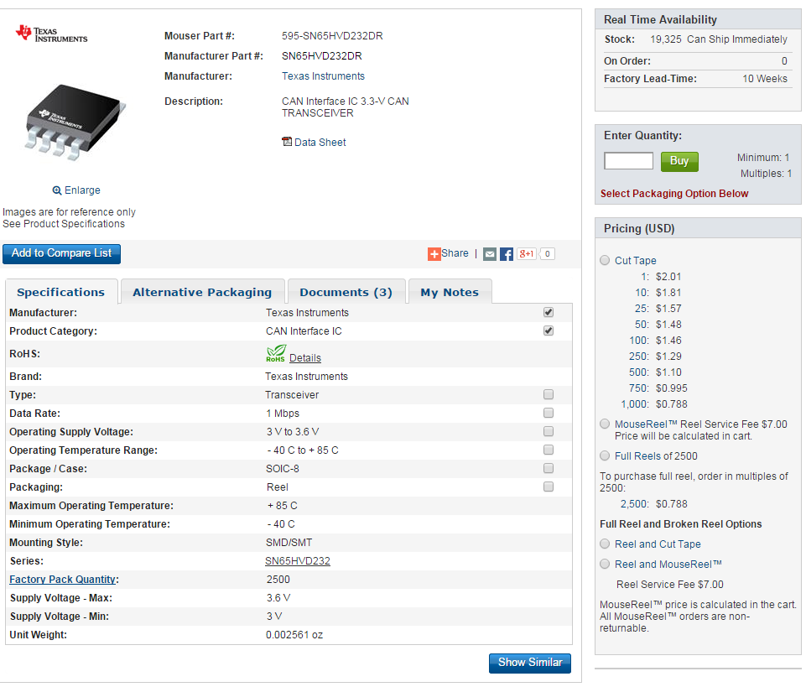

[**Second CanBus Tranreciever**](http://html.alldatasheet.com/html-pdf/185387/TI/VP232/22/1/VP232.html)**: $1.49 each**

<http://www.mouser.com/ProductDetail/Texas-Instruments/SN65HVD230QDR/?qs=sGAEpiMZZMutXGli8Ay4kMj2H7jHcXU%2f5b%252bR1pNiiZ4%3d>

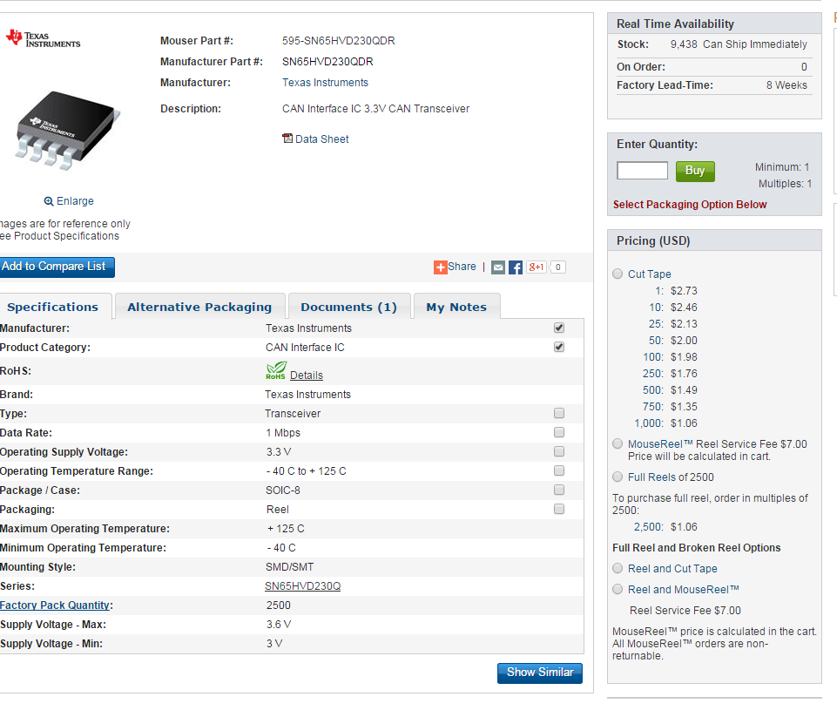

**N65HVD230x 3.3-V CAN Bus Transceiver**

Designed for operation in especially harsh environments, these devices feature cross wire protection, loss of ground and overvoltage protection, overtemperature protection, as well as wide common mode range of operation.

The CAN transceiver is the CAN physical layer and interfaces the single ended host CAN protocol controller with the differential CAN bus found in industrial, building automation, and automotive applications. These devices

operate over a -2 V to 7 V common mode range on the bus, and can withstand common mode transients of ±25

**Power Inductor:**

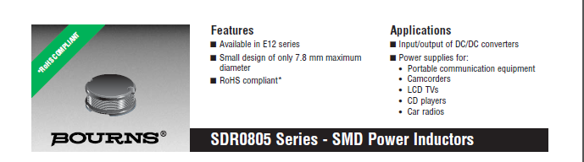

Power inductors play an important role in voltage conversion applications by yielding lower core losses

They are also used to store energy, filter EMI noise, and provide lower signal loss in system designs. The increased utilization of battery powered miniaturized portable electronics such as mobile phones, notebook PCs, and handheld game devices has led to the added use of these popular, small-sized SMD power inductors into system designs.

A power inductor is an electronic component which receives as well as stores electrical energy by using a magnetic field. This magnetic field is usually created with a tightly coiled conductive wire. A power inductor maintains a steady current in an electrical circuit with a varying current and/or voltage.

**Anti Spark Circuit:** to avoid spark occurs from the capacitor in the ESC.

**http://www.raptortechnique.com/gaui/antispark.htm**

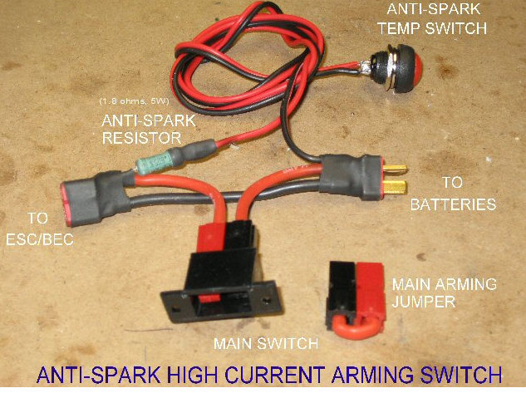

Use this circuit for the Antispark built in the battery packet.

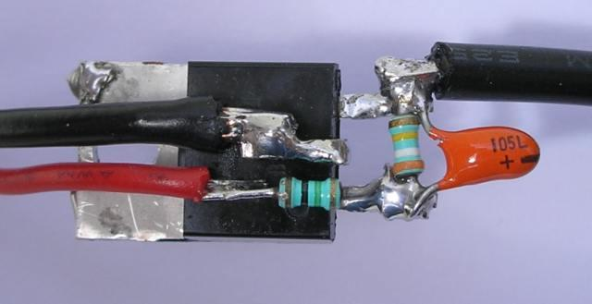

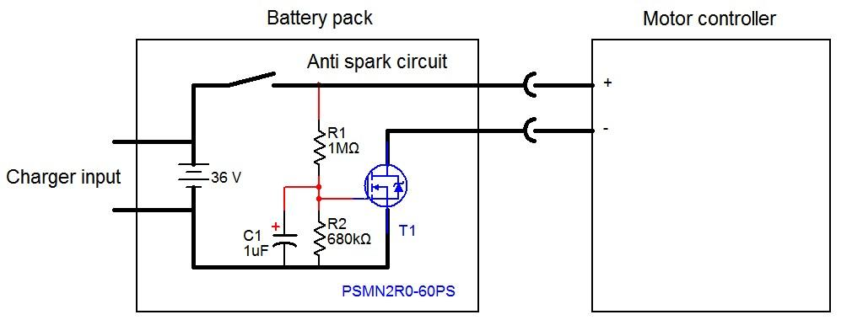

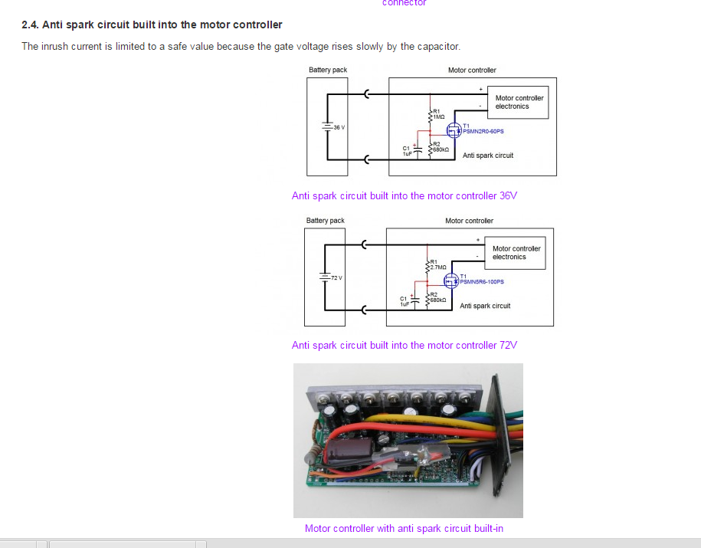

<http://avdweb.nl/solar-bike/electronics/motor-controller.html#h1-2-motor-controller-selection>

**Frequency controller**: ABM3B

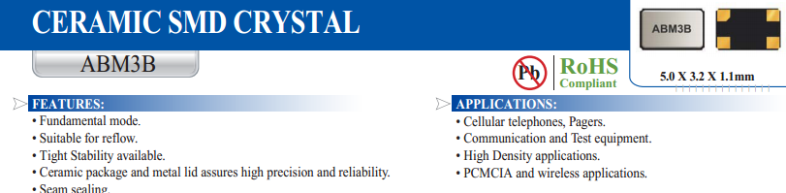

**MCU:**

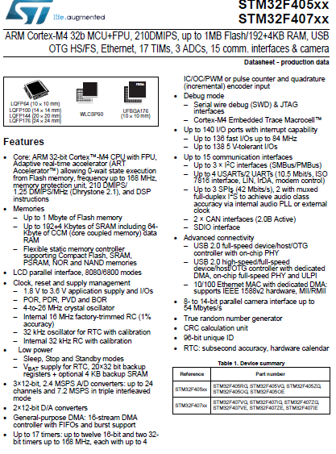

**Voltage Regulation:**

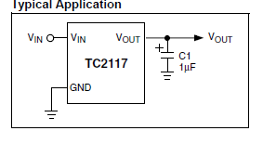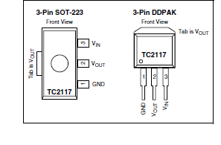

The TC2117 is a fixed, high accuracy (typically ±0.5%) CMOS low dropout regulator. Designed specifically for battery operated systems, the TC2117’s CMOS construction eliminates wasted ground current,significantly extending battery life. Total supply current is typically 80A at full load (20 to 60 times lower than in bipolar regulators*).*

Top 2 Transistor:

|  |
| --- |
| <http://www.mouser.com/ProductDetail/International-Rectifier/IRFH7440TRPbF/?qs=sGAEpiMZZMshyDBzk1%2fWi9ZL%252bu09nRqGcGvej6ZVTek%3d>    cost $ 0.629 each  <http://www.mouser.com/ProductDetail/Fairchild-Semiconductor/FDMS8350L/?qs=sGAEpiMZZMshyDBzk1%2fWixaibETDa%252baeLZjK6xMS48m4JEJhEzEdvQ%3d%3d>    <http://www.mouser.com/ProductDetail/STMicroelectronics/STL260N3LLH6/?qs=sGAEpiMZZMshyDBzk1%2fWi0dsXOGve85xKY7IcZD8qaVWq%2fYNXVF98w%3d%3d> |

<http://cache.freescale.com/files/microcontrollers/doc/ref_manual/DRM078.pdf>

<https://www.youtube.com/watch?v=8xvT4A7fWNA>

**Gate Driver:**

**A gate driver is a** [**power amplifier**](http://en.wikipedia.org/wiki/Power_amplifier) **that accepts a low-power input from a controller** [**IC**](http://en.wikipedia.org/wiki/Integrated_circuit) **and produces a high-current drive input for the gate of a high-power transistor such as an** [**IGBT**](http://en.wikipedia.org/wiki/IGBT) **or** [**power MOSFET**](http://en.wikipedia.org/wiki/Power_MOSFET)**. Gate drivers can be provided either on-chip or as a discrete module. In essence, a gate driver consists of a** [**level shifter**](http://en.wikipedia.org/wiki/Comparator#Level_shifter) **in combination with an** [**amplifier**](http://en.wikipedia.org/wiki/Amplifier)**.**

**Top 2:**

**Gate Drive 1: DRV8302 : cost $4.59**

http://www.ti.com/lit/ds/symlink/drv8302.pdf

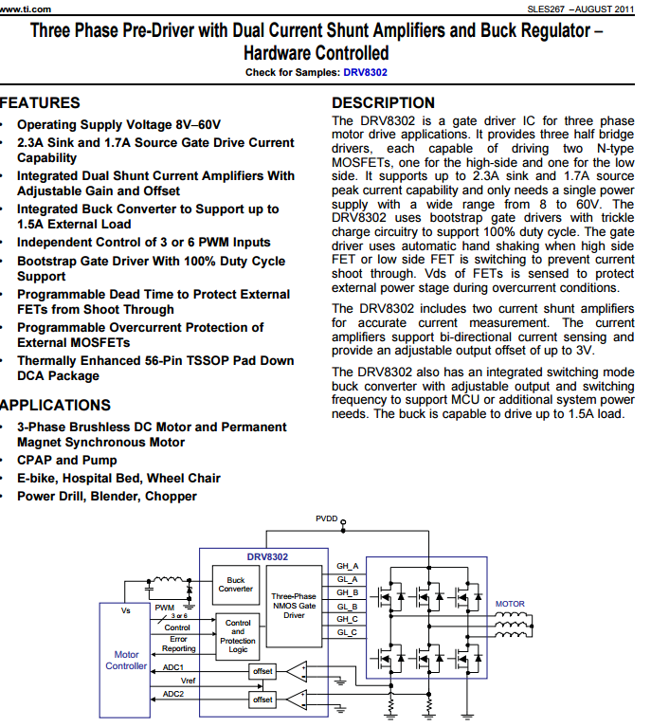

**Gate Drive 2: DRV 8301 : cost $ 4.18**

http://www.ti.com/lit/ds/symlink/drv8301.pdf

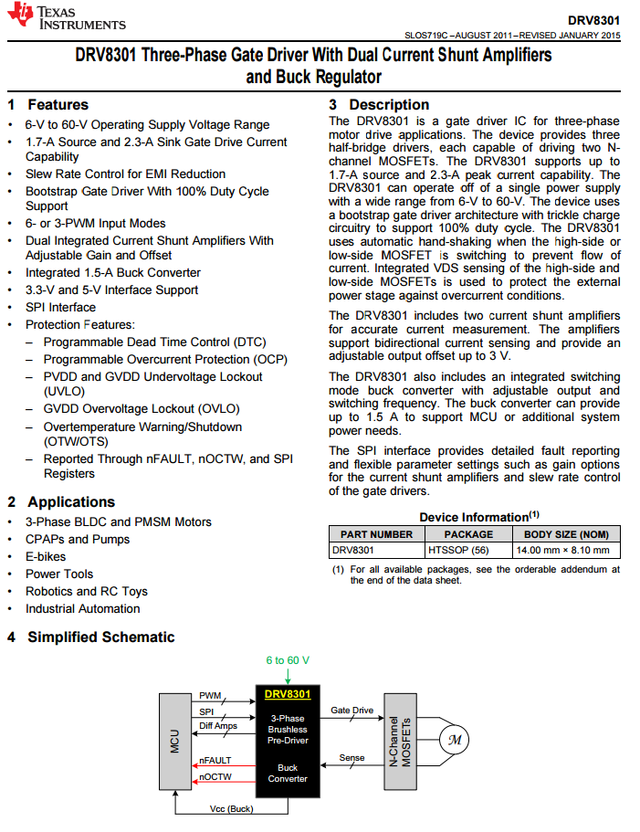

**Gate Drive 3: cost $2.79**

<http://www.mouser.com/ProductDetail/Freescale-Semiconductor/MC34937APEK/?qs=sGAEpiMZZMttKWgNLnZcJoBJwLh9fVzc>

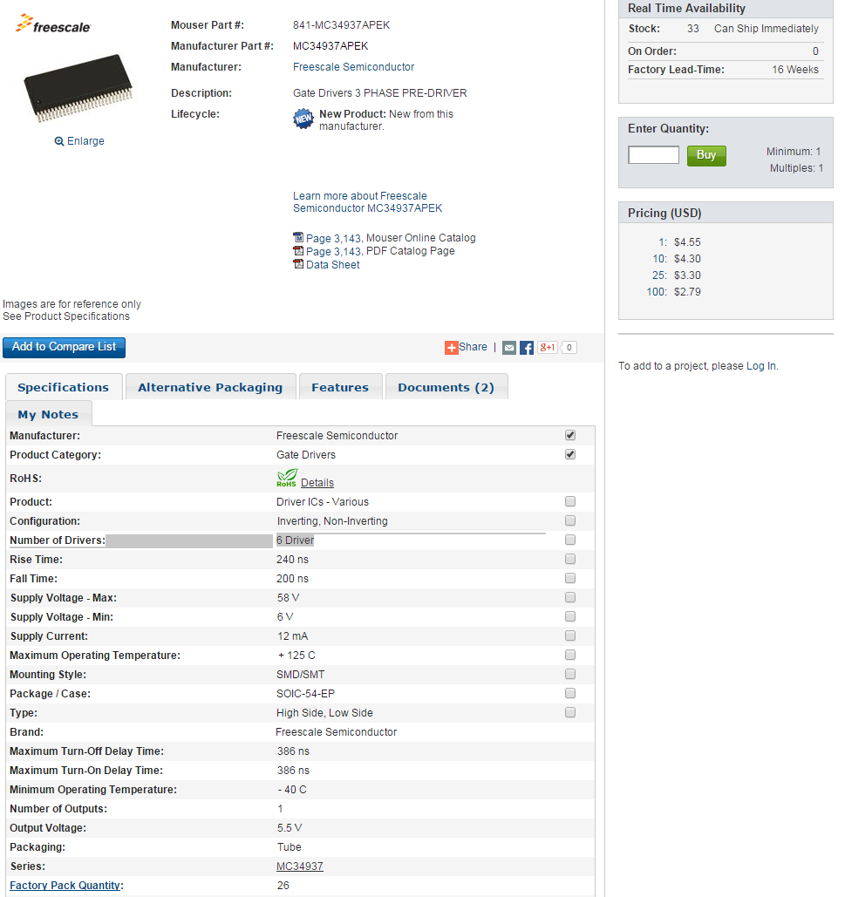

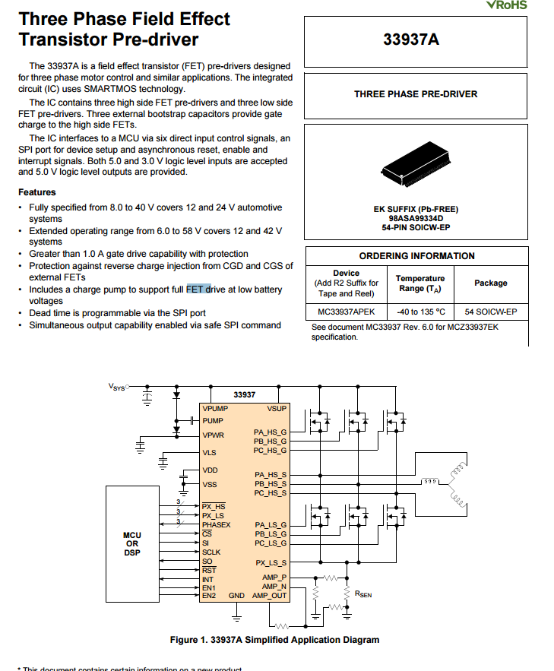

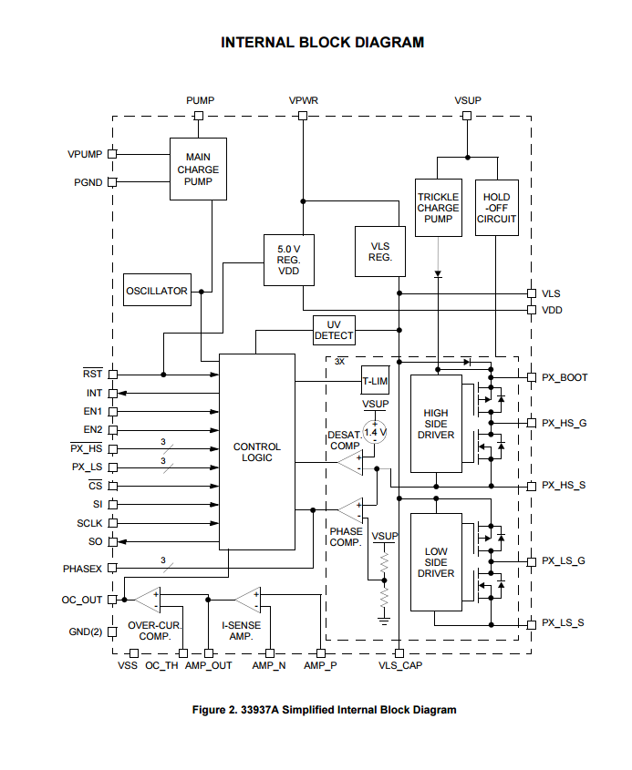

**Guy gate: $4**

<http://www.mouser.com/ProductDetail/Texas-Instruments/DRV8302DCAR/?qs=sGAEpiMZZMs0JQbjv5Ir6h9FrTVstRQs>

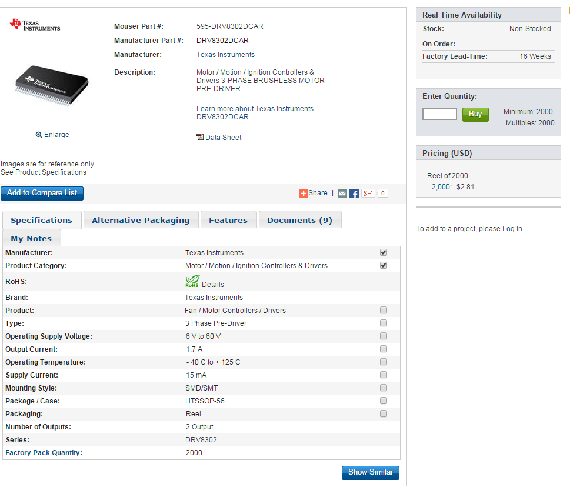

Gate Driver 3: $ 2.83

http://www.mouser.com/ProductDetail/International-Rectifier/IRS2336DSTRPBF/?qs=sGAEpiMZZMvQcoNRkxSQkuprlmO3q%2f%2f3Us%2fSIT%252bvfkg%3d

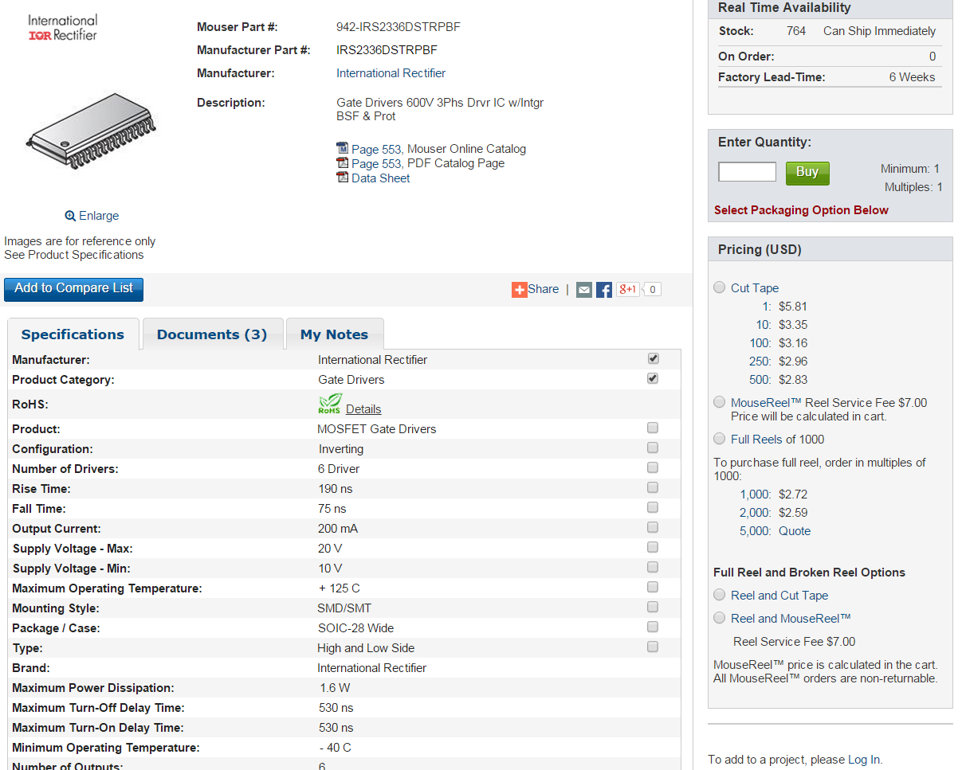

bluetooth

1. <http://www.mouser.com/ProductDetail/ACKme-Networks/AMS002-S/?qs=%2fha2pyFadug4qOUm2JYZX4JmPMT06ZgS3P%252beFdt1s17LJT%2fK5YdpJw%3d%3d>

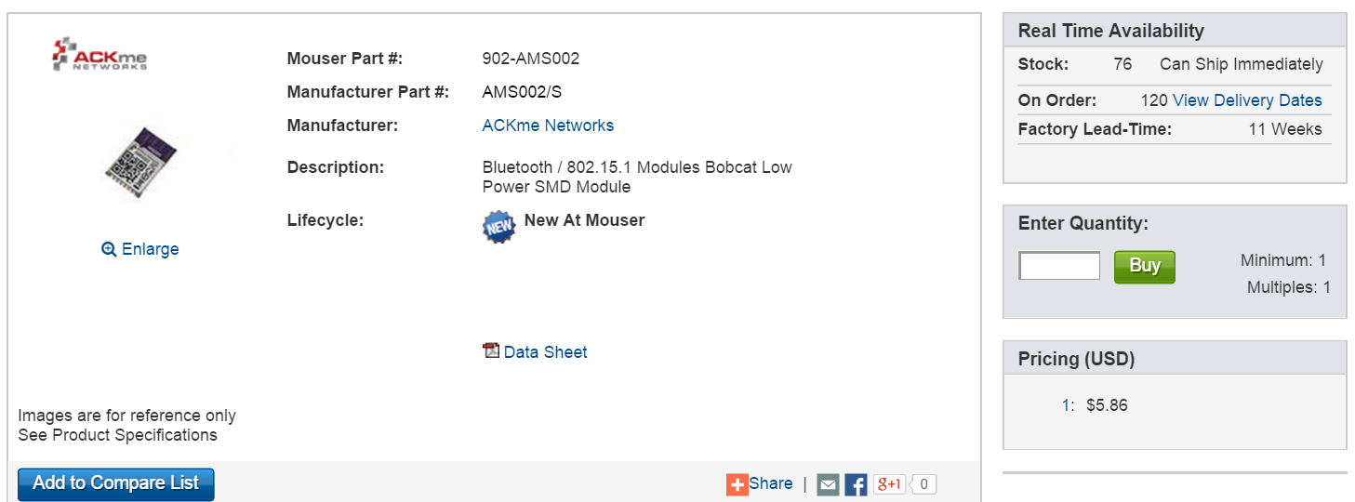

bluetooth

2.

<http://www.mouser.com/ProductDetail/Microchip-Technology/RN4020-V-RM/?qs=sGAEpiMZZMsF1ODjcwEocHyCFP%2fwHEaf%2fRIhh6nv4Qk%3d>

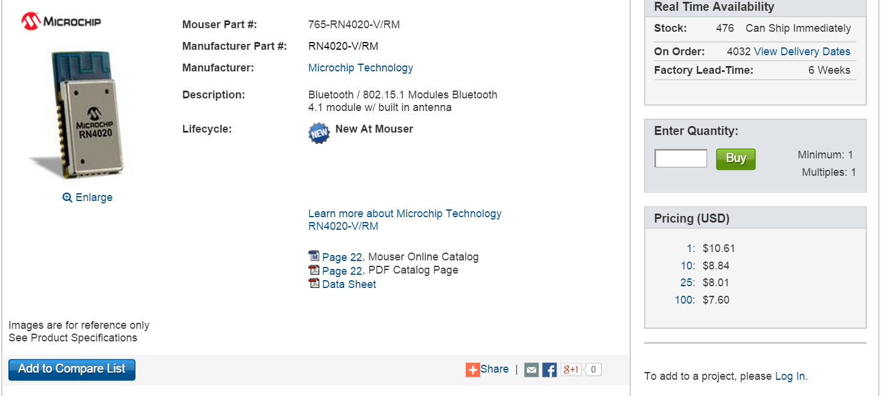

Bluetooth

3. <http://www.mouser.com/ProductDetail/Taiyo-Yuden/EYSFCNZXX/?qs=sGAEpiMZZMvxVoyCXc2K7uYPOm4ZM2m0C%2fZajN42Wr0%3d>

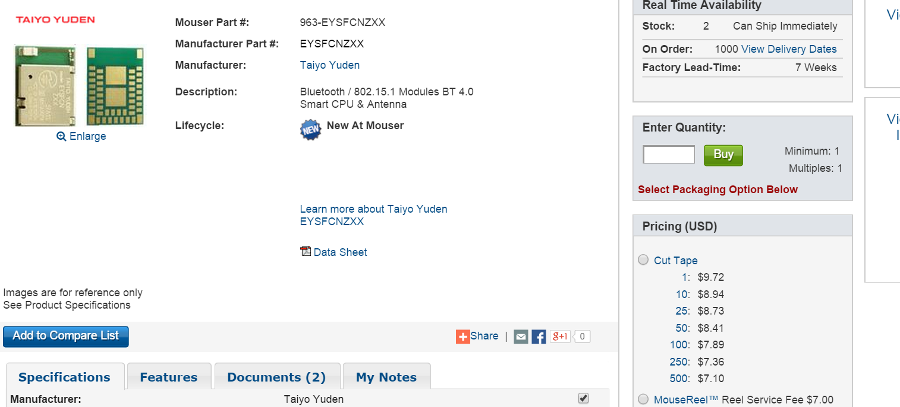

**Hall effect sensor:** A **Hall** effect **sensor** is a transducer that varies its output voltage in response to a magnetic field.

*Power consumption is calculated as supply voltage (3.3v) times current supply

1. P= (3V * 0.001mA) = 3uW, $0.193 (1000)

<http://www.mouser.com/ProductDetail/Diodes-Incorporated/AH180N-WG-7/?qs=sGAEpiMZZMsn4oxpmZ83zm1PRmazBdnM>

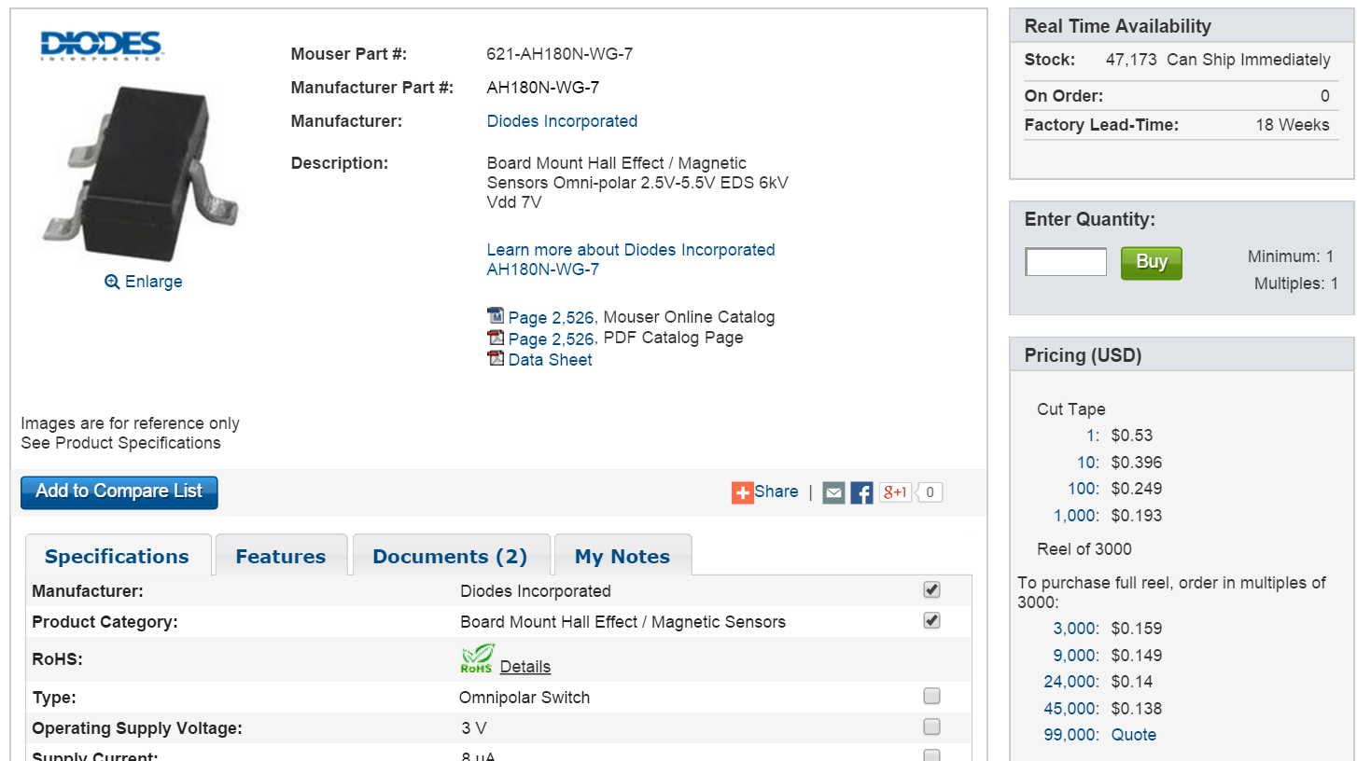

2. P = 33uW, $0.177 (1000)

<http://www.mouser.com/ProductDetail/Diodes-Incorporated/AH9248Z3-G1/?qs=sGAEpiMZZMtqO%252bWUGLBzeEjxb7pbAsUuuRyt%2fnN%252bibc%3d>

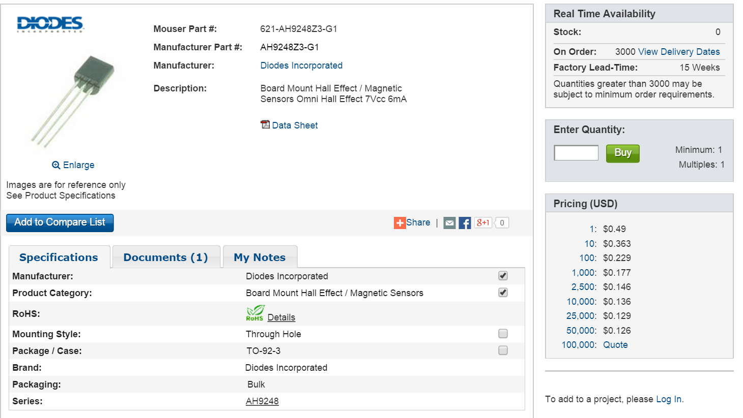

3. P =(3.3V) * (5uA) = 16.5uW, $0.204 (1000)

<http://www.mouser.com/ProductDetail/ROHM-Semiconductor/BU52056NVX-TR/?qs=sGAEpiMZZMuDoreBxlZoyBK7DaXcS6mC>

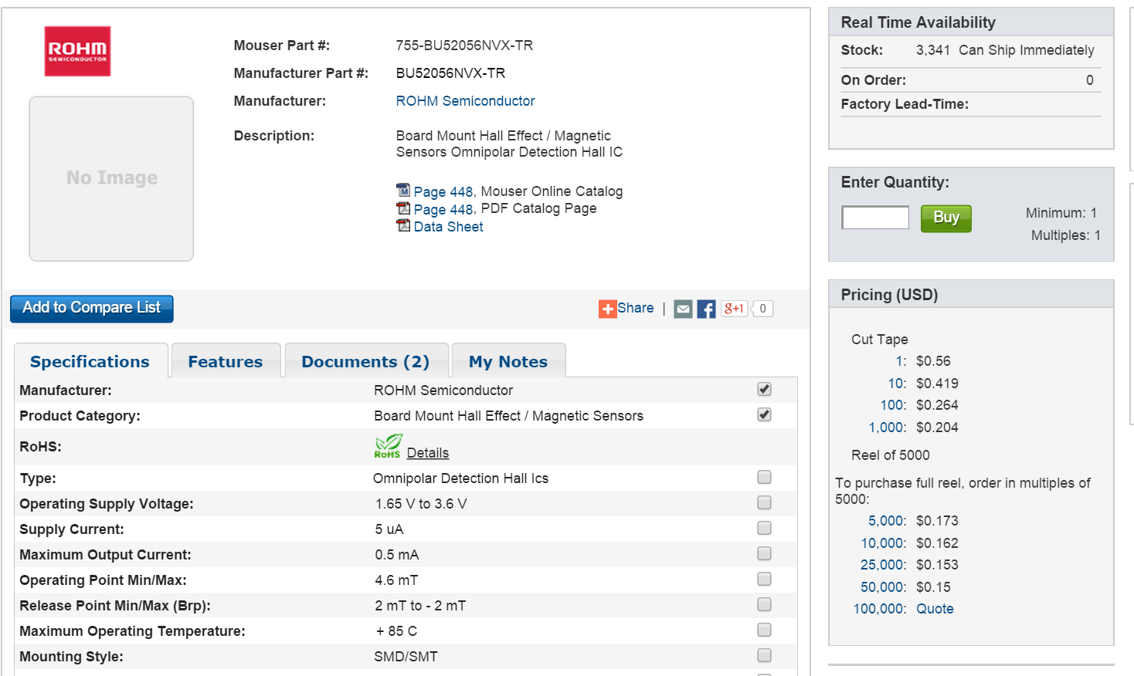

4. power consumption 10uW, $0.265 (1000)

<http://www.mouser.com/ProductDetail/Murata-Electronics/MRMS301A/?qs=sGAEpiMZZMu0f%252bT2bkVfus95UmFFOWmU3TR8i%2fLHlYw%3d>

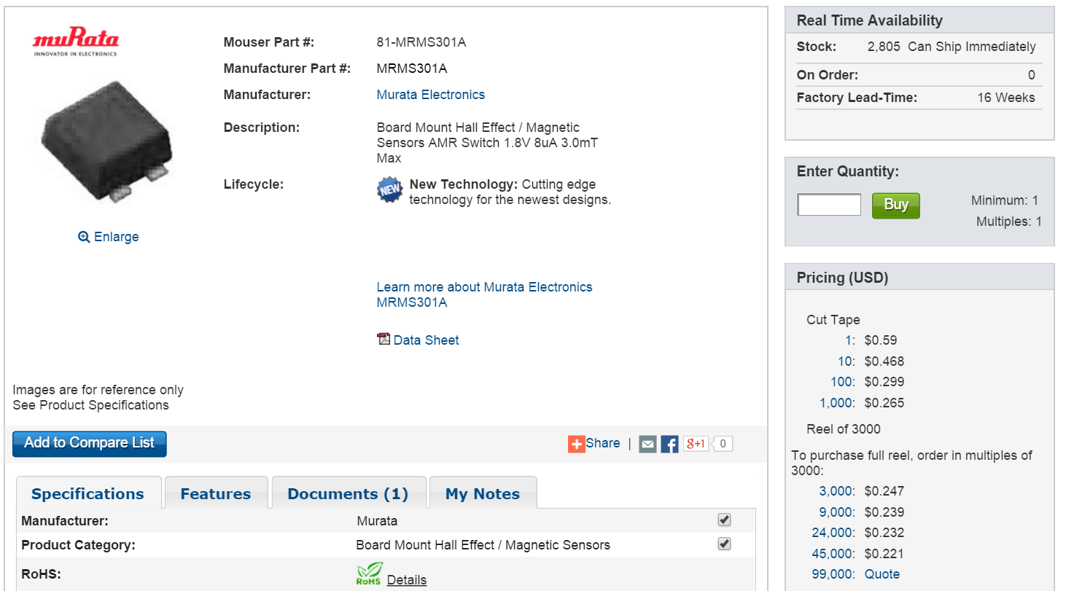

5. P = (3.3V) * (7.2uA) = 2.4uW, $0.24 (1000)

<http://www.mouser.com/ProductDetail/Diodes-Incorporated/AH1895-FA-7/?qs=sGAEpiMZZMukBJem%252bjLAJ5GLfuNLUU3M>

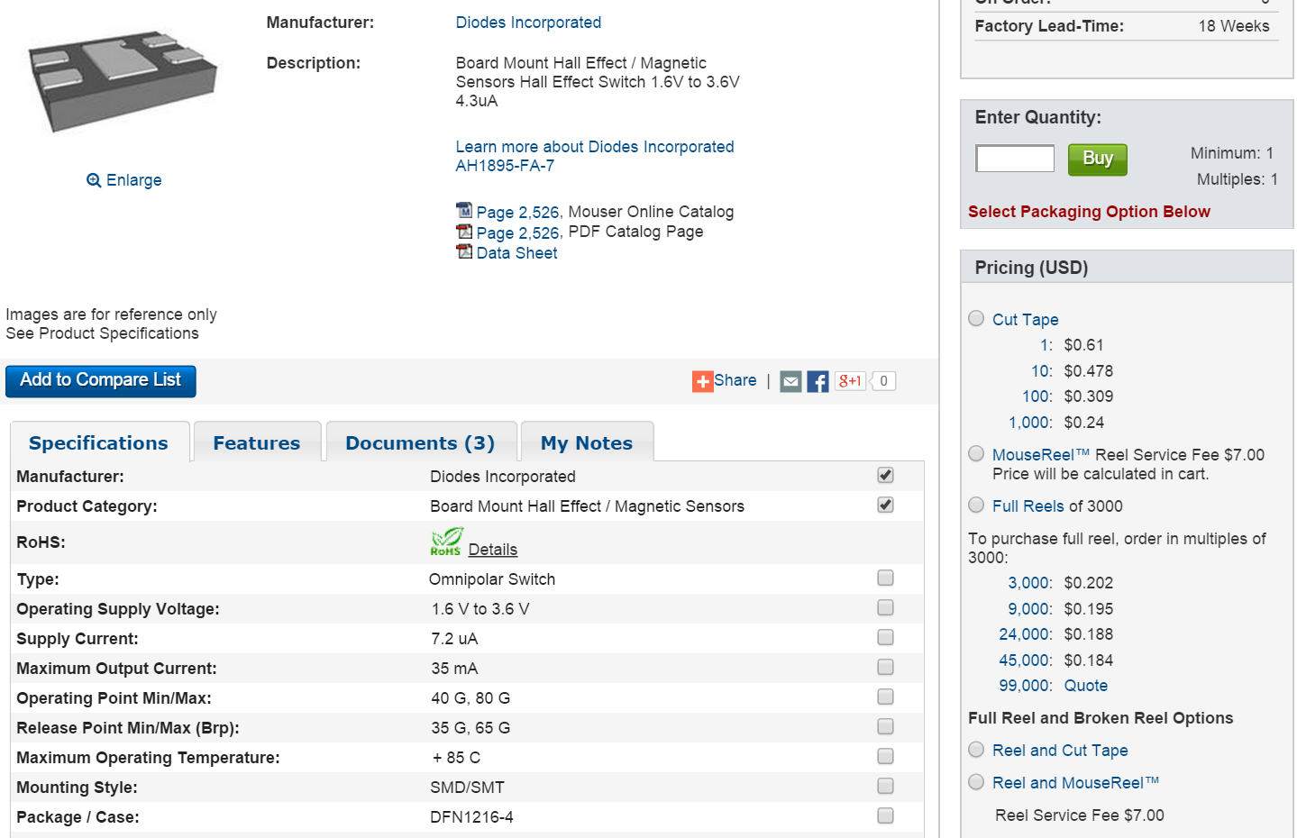

**Thermistors: A thermistor is a type of** [**resistor**](http://en.wikipedia.org/wiki/Resistor) **whose** [**resistance**](http://en.wikipedia.org/wiki/Electrical_resistance) **varies significantly with** [**temperature**](http://en.wikipedia.org/wiki/Temperature)**, more so than in standard resistors.**

**We assume the average operating temperature to be 75C**

**1 4.7k @ 25C, 743 @ 75C, $0.174 (1000)**

[**http://www.mouser.com/ProductDetail/Vishay-BC-Components/NTCS0603E3472HHT/?qs=sGAEpiMZZMuBd0%252bwiCVS23WR6Ij350MUO4jgHsYM5Ag%3d**](http://www.mouser.com/ProductDetail/Vishay-BC-Components/NTCS0603E3472HHT/?qs=sGAEpiMZZMuBd0%252bwiCVS23WR6Ij350MUO4jgHsYM5Ag%3d)

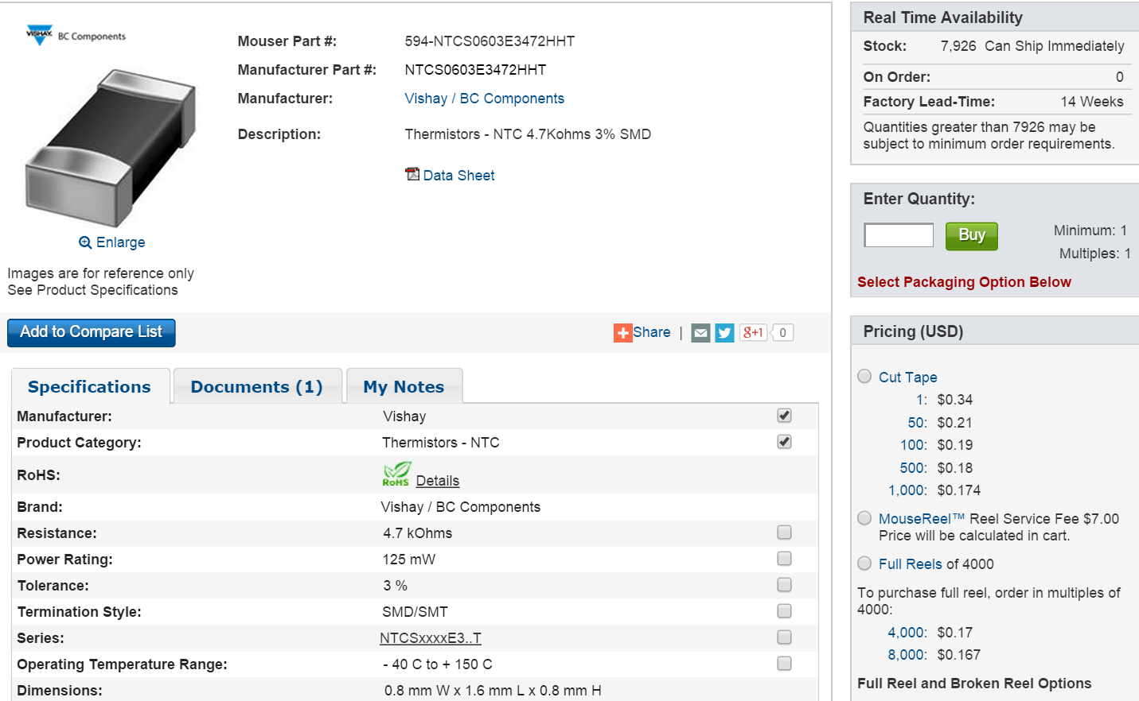

**2. 10K @ 25C, 1.93 @ 75C, $0.136 (1000)**

[**http://www.mouser.com/ProductDetail/Vishay-BC-Components/NTCS0603E3103JLT/?qs=sGAEpiMZZMuBd0%252bwiCVS20cdM95KJted61%252bW5Ck5%2flw%3d**](http://www.mouser.com/ProductDetail/Vishay-BC-Components/NTCS0603E3103JLT/?qs=sGAEpiMZZMuBd0%252bwiCVS20cdM95KJted61%252bW5Ck5%2flw%3d)

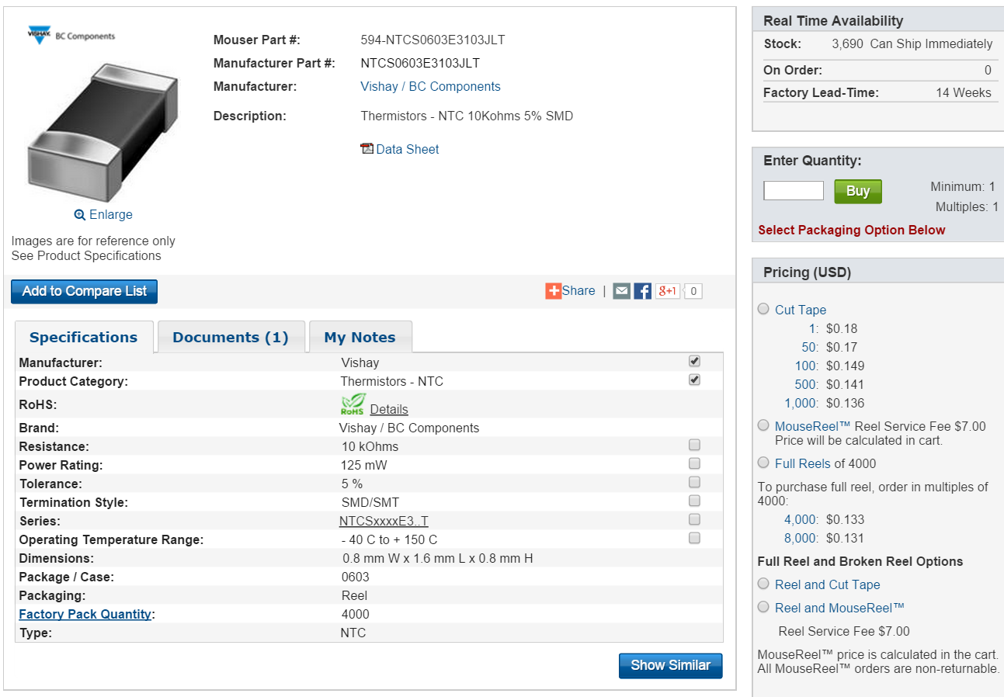

**3. 15K @ 25C, 2663.2 @ 75C, $ 0.135 (1000)**

[**http://www.mouser.com/ProductDetail/Vishay-BC-Components/NTCS0603E3153JMT/?qs=sGAEpiMZZMuBd0%252bwiCVS23WR6Ij350MUdyC%252bm84Ah4w%3d**](http://www.mouser.com/ProductDetail/Vishay-BC-Components/NTCS0603E3153JMT/?qs=sGAEpiMZZMuBd0%252bwiCVS23WR6Ij350MUdyC%252bm84Ah4w%3d)

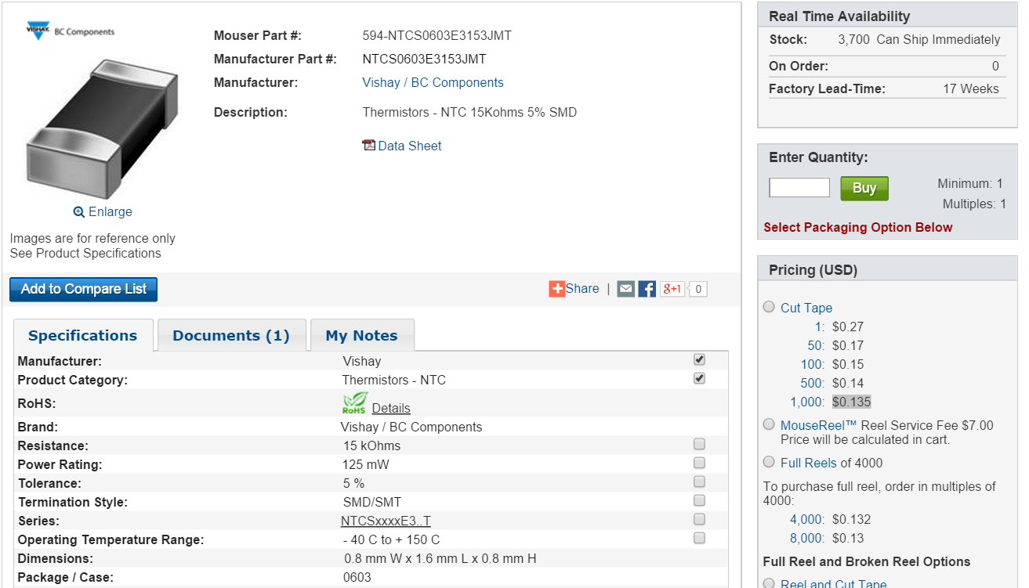

**4.** [**http://www.mouser.com/ProductDetail/Vishay-BC-Components/NTCS0402E3103JLT/?qs=sGAEpiMZZMuBd0%252bwiCVS23WR6Ij350MUz18SH99m8J4%3d**](http://www.mouser.com/ProductDetail/Vishay-BC-Components/NTCS0402E3103JLT/?qs=sGAEpiMZZMuBd0%252bwiCVS23WR6Ij350MUz18SH99m8J4%3d)

**5.** [**http://www.mouser.com/ProductDetail/AVX/NB12P00104JBB/?qs=sGAEpiMZZMuBd0%252bwiCVS23ixOKDDAupTIYfXniuuZOg%3d**](http://www.mouser.com/ProductDetail/AVX/NB12P00104JBB/?qs=sGAEpiMZZMuBd0%252bwiCVS23ixOKDDAupTIYfXniuuZOg%3d)

**Current Resistors**

[**http://www.mouser.com/ProductDetail/Ohmite/FCSL90R001JER/?qs=sGAEpiMZZMtlleCFQhR%2fzazo7zkTM5%252b8waxRSzopCYI%3d**](http://www.mouser.com/ProductDetail/Ohmite/FCSL90R001JER/?qs=sGAEpiMZZMtlleCFQhR%2fzazo7zkTM5%252b8waxRSzopCYI%3d)

**cost: $0.20**

**R = 4m ohms**

**Power Rate: 2W**

[**http://www.mouser.com/ProductDetail/Bourns/CRE2512-FZ-R004E-2/?qs=sGAEpiMZZMukHu%252bjC5l7YdPw%252bq7Sy9UM47RQ76azUnM%3d**](http://www.mouser.com/ProductDetail/Bourns/CRE2512-FZ-R004E-2/?qs=sGAEpiMZZMukHu%252bjC5l7YdPw%252bq7Sy9UM47RQ76azUnM%3d)

**Cost : $0.205**

**R = 1m ohms**

**Power Rate: 3W**

[**http://www.mouser.com/ProductDetail/Bourns/CRE2512-FZ-R001E-3/?qs=sGAEpiMZZMukHu%252bjC5l7YdPw%252bq7Sy9UMysd9uExSQys%3d**](http://www.mouser.com/ProductDetail/Bourns/CRE2512-FZ-R001E-3/?qs=sGAEpiMZZMukHu%252bjC5l7YdPw%252bq7Sy9UMysd9uExSQys%3d)

**Resistors (1.93K)**

**For thermistor No.1**

1. **$0.017, (1000)**

[**http://www.mouser.com/ProductDetail/Yageo/MFR-12FTF52-1K93/?qs=sGAEpiMZZMtlubZbdhIBIOunD5kldQozof3fiiIciKE%3d**](http://www.mouser.com/ProductDetail/Yageo/MFR-12FTF52-1K93/?qs=sGAEpiMZZMtlubZbdhIBIOunD5kldQozof3fiiIciKE%3d)

**2. $ 0.011 (5000)**

[**http://www.mouser.com/ProductDetail/Yageo/RT0603DRE071K93L/?qs=sGAEpiMZZMtlubZbdhIBIKhKtNYK57pi9uWW1M6tNVw%3d**](http://www.mouser.com/ProductDetail/Yageo/RT0603DRE071K93L/?qs=sGAEpiMZZMtlubZbdhIBIKhKtNYK57pi9uWW1M6tNVw%3d)

**3. $ 0.052 (5000)**

[**http://www.mouser.com/ProductDetail/Yageo/RT0805BRD071K93L/?qs=sGAEpiMZZMtlubZbdhIBIKhKtNYK57pizFF%252bLNScUgI%3d**](http://www.mouser.com/ProductDetail/Yageo/RT0805BRD071K93L/?qs=sGAEpiMZZMtlubZbdhIBIKhKtNYK57pizFF%252bLNScUgI%3d)

**For thermistor No.2 (1.93K)**

1. **$0.017 (1000)**

[**http://www.mouser.com/ProductDetail/Yageo/MFR-12FTF52-1K93/?qs=sGAEpiMZZMtlubZbdhIBIOunD5kldQozof3fiiIciKE%3d**](http://www.mouser.com/ProductDetail/Yageo/MFR-12FTF52-1K93/?qs=sGAEpiMZZMtlubZbdhIBIOunD5kldQozof3fiiIciKE%3d)

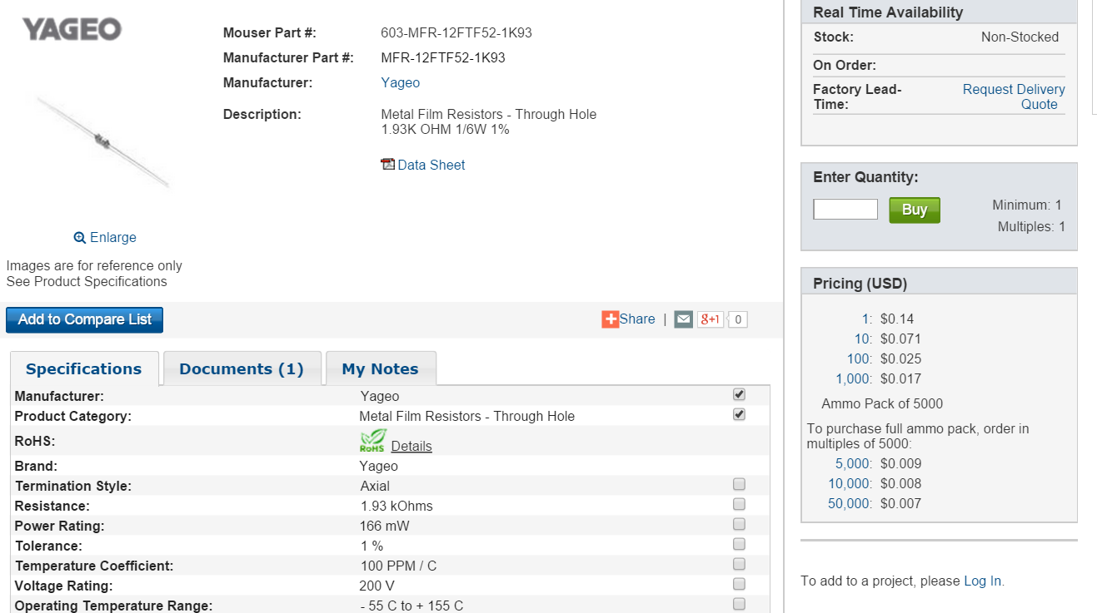

**2. $0.011 (5000)**

[**http://www.mouser.com/ProductDetail/Yageo/RT0603DRE071K93L/?qs=sGAEpiMZZMtlubZbdhIBIKhKtNYK57pi9uWW1M6tNVw%3d**](http://www.mouser.com/ProductDetail/Yageo/RT0603DRE071K93L/?qs=sGAEpiMZZMtlubZbdhIBIKhKtNYK57pi9uWW1M6tNVw%3d)

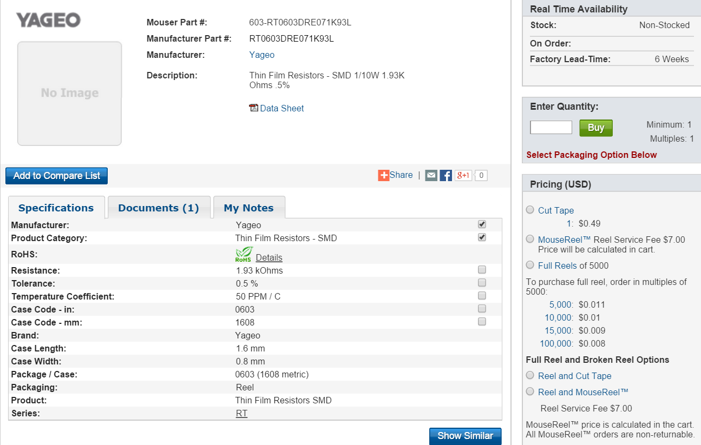

**For thermistor 3 (2.663k)**

1. **$0.03 (3000)**

[**http://www.mouser.com/ProductDetail/Vishay-Beyschlag/MMA02040C2671FB300/?qs=sGAEpiMZZMtlubZbdhIBIC9ec1oeE8e8nK2dIolzuZU%3d**](http://www.mouser.com/ProductDetail/Vishay-Beyschlag/MMA02040C2671FB300/?qs=sGAEpiMZZMtlubZbdhIBIC9ec1oeE8e8nK2dIolzuZU%3d)

**2. $0.041 (1000)**

[**http://www.mouser.com/ProductDetail/Vishay-Dale/RN55D2671FRE6/?qs=sGAEpiMZZMtlubZbdhIBIEoyciyih%2fcoNdn0tPZueB8%3d**](http://www.mouser.com/ProductDetail/Vishay-Dale/RN55D2671FRE6/?qs=sGAEpiMZZMtlubZbdhIBIEoyciyih%2fcoNdn0tPZueB8%3d)

**3. $0.01 (1000)**

[**http://www.mouser.com/ProductDetail/Panasonic/ERJ-8ENF2671V/?qs=sGAEpiMZZMtlubZbdhIBIOIpaOjkYUZGMI7Ap8YWzCA%3d**](http://www.mouser.com/ProductDetail/Panasonic/ERJ-8ENF2671V/?qs=sGAEpiMZZMtlubZbdhIBIOIpaOjkYUZGMI7Ap8YWzCA%3d)